caBIG-IMG-99-01-31052006
The eXtensible Imaging Platform

Software Design Description

Version 1.0

29 February 2008

Document Change Record
Version Number | Date | Description
1.0 | 29 February | Initial document

TABLE OF CONTENTS
1. Introduction 1
2. System Architecture 2
3. Components 4
3.1 XIP Host 4
3.2 XIP Application Libraries 4
3.3 XIP ApplicationS 5
3.4 XIP Application Builder 6
Appendix A – acronym List 7

Introduction
The Software Design Description (SDD) describes the design decisions, architectural design, and the high level design needed to implement the eXtensible Imaging Platform Release 1.0 software. It provides the acquirer visibility into the design and provides information needed for software support.
The requirements driving this design are specified in the eXtensible Imaging Project Requirements Specification. The eXtensible Imaging Project Requirements Traceability Matrix maps the requirements to the three major sections of the design specification: the XIP Host, the XIP Libraries, and XIP Applications.
The XIP is primarily a development environment, commissioned by NCI’s caBIG™ program that facilitates the rapid creation of portable, task specific applications. The goal of the first year of the project is not a monolithic application for any particular task, but rather a set of tools and libraries for creating such applications.
The XIP follows the paradigm proposed by DICOM Working Group 23 “Application Hosting” of separating out infrastructure common to all applications, such as network access, database management, and security, into a Hosting System. This Hosting System then launches and manages a set of Hosted Applications, assigning them tasks, supplying them with data, and collecting the results that they create. Since the Hosting System manages the infrastructure, the Hosted Application need only worry about the business logic of the application. XIP Release 1.0 follows an early draft of DICOM Supplement 118, which further describes this Application Hosting interface. Additional information about DICOM WG-23 and Supplement 118 can be found at the DICOM web site (http://dicom.nema.org).

- Section 2. System Architecture: Describes and overview of the system, the conceptual and architectural design, interfaces and the various environments that will be used throughout the development lifecycle.
- Section 3. Components: Identifies and describes each component broken down into its parts that are described in detail.
- [Section 4. Notes: Contains general information that aids in the understanding of this document.]

System Architecture
The XIP run time environment (e.g. a workstation) consists of three principle software components (see figure 1):
- The XIP Host – the XIP Host software implements the Hosting System side of the DICOM WG-23 Application Hosting interface, and that supplies the common infrastructure utilized by all applications.
- The XIP Application Libraries – the library modules (often shortened to XIP Libraries) that provide image processing and visualization functions that an application developer may use to create new XIP Applications. Most of the XIP Application Libraries are provided as extensions to the Open Inventor™ libraries, and are utilized via the building of scene graphs and pipelines. One special application library provides an implementation of the Hosted Application side of the DICOM WG-23 Application Hosting interface.
- Multiple XIP Applications – the software that supplies the business logic for performing particular tasks, generally through the use of the XIP Application Libraries. XIP Applications in particular must react to actions triggered by and data provided by the XIP Host, as well as return any results and report events back to the XIP Host through the DICOM WG-23 Application Hosting interface.
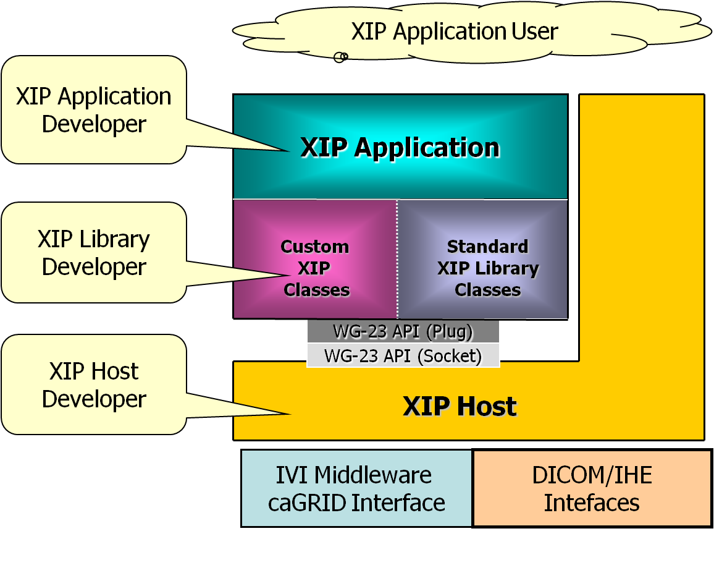
Note that each of these components can be built independently of each other. In fact, often they are developed by different teams.
Because of the use of the DICOM WG-23 Application Hosting interfaces, an XIP Application can be run by any system that implements the Hosting System side of that interface. It is expected that multiple commercial as well as open source products will appear over the next few years that supply the Hosting System side of the DICOM WG-23 Application Hosting interfaces (see figure 2). Hence, the goal is that an XIP Application should be able to run on any of these products. This implies that an XIP Application should have no dependencies on the XIP Host, nor make no assumptions about its run time environment other than what is provided by the DICOM WG-23 Application Hosting interfaces.
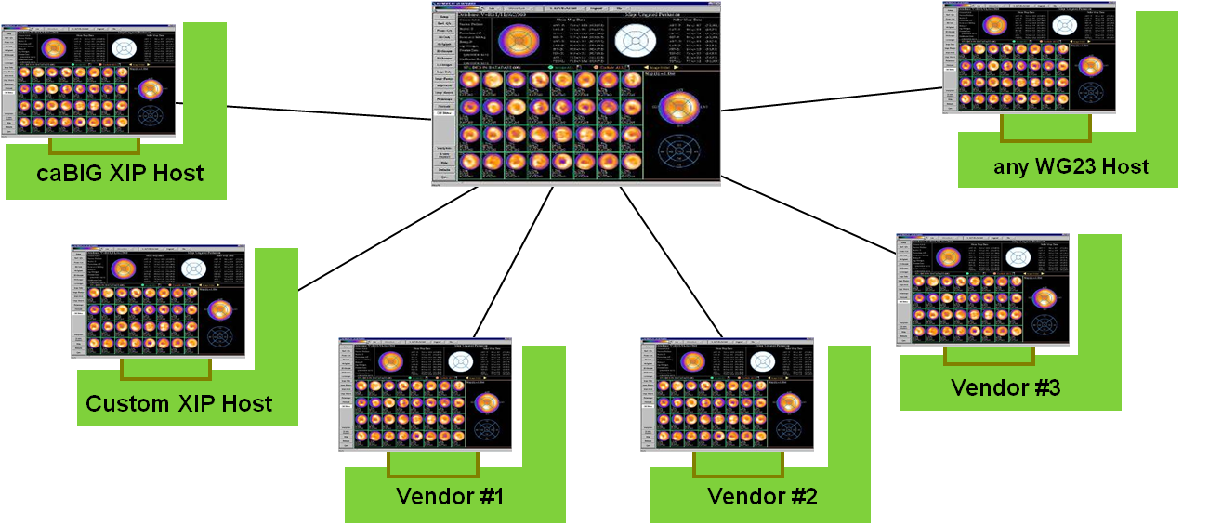
Conversely, it is expected that many commercial as well as open source applications will appear over the next few years that utilize the Hosted Application side of the DICOM WG-23 Application Hosting interfaces. These application may not necessarily use the XIP Application Libraries. The goal is that the XIP Host should be able to run any of these applications, given available resources (hardware, memory, libraries, etc.), which implies that the XIP Host should assume no connections with running applications other than what is provided by the DICOM WG-23 Application Hosting interfaces.
An Open Inventor™ scene graph editor, known as the XIP Application Builder (often shortened to just XIP Builder) facilitates the use of the XIP Application Libraries. It is not required to run XIP Applications, hence is not part of the XIP run time environment. An application developer may use the XIP Builder, if desired, to create the scene graphs of XIP Application Library modules for use in the XIP Application he or she is developing. The visual, drag and drop nature of the XIP Application Builder scene graph editor contributes greatly to the speed with which application developers can create and debug applications.

Components

XIP Host
The XIP Host is layered on top of the IVI Middleware for caGrid connectivity and security, coupled with the PixelMed DICOM Toolkit for interactions with other DICOM Application Entities on the network.
The GUI for the XIP Host is built using Java Swing. The basic guiding principle was to reserve as much screen real estate as possible for use by the running XIP Applications, while still providing access to controls that allow a user to:
- select worklist entries, which automatically locate input data and then launch applications to process that data,
- search for data on caGrid Image Data Services, on DICOM Storage Services, or on the local file system,
- retrieve data found and provide it as input to XIP applications that the user launches,
- switch between running XIP applications,
- configure various aspects of the XIP host,
- utilize debugging functions to insure proper operation of the interfaces.
The XIP Host internally includes logic to track the running applications, and accept results data from them through the DICOM WG-23 Application Hosting interfaces. It uses the JAX-WS system that is part of the Sun Java 6.0 distribution to implement those interfaces. The DICOM WG-23 Application Hosting interfaces are described in Supplement 118 of the DICOM Standard. The WSDL and XML schema definitions, as well as UML model diagrams of these interfaces are included in the XIP documentation and software.

XIP Application Libraries
The main portions of the XIP Application Libraries are extensions built on top of the Open Inventor™ framework. They are written in c++ for compatibility with the base Open Inventor libraries, and for optimal performance. The design and use of the Open Inventor framework is described in the book “The Inventor Mentor” (ISBN-13: 978-0201624953). The book “The Inventor Toolmaker” (ISBN-13: 978-0201624939) describes how to extend the base Open Inventor libraries. Those two books are the base documentation on the how the Open Inventor extensions within the XIP Application Libraries are built.
XIP Release 1.0 includes the following Open Inventor™ extension libraries:
- XipIvCore: An Inventor extension library for basic data types needed in medical imaging.
- XipIvCoreGl: An extension library for enhanced OpenGL features that are not supported in the original Open Inventor library.
- XipIvOverlay: A library providing a set of overlay (markup) objects for annotating images and performing measurements.
- XipIvRenderer: A modular, configurable volume renderer for three-dimensional image data.
- XipIvDicom: A library for basic DICOM support based on the Offis DCMTK toolkit.
- XipIvITK: A project whose goal is providing scene objects for the Insight Segmentation and Registration Toolkit (ITK).
- XipIvVTK: A project whose goal is providing scene objects for the Visualization Toolkit (VTK).
In addition to the Open Inventor™ extensions, the XIP Application libraries include two Java classes, with associated support routines:
- ivCanvas: A JNI-based class derived from the Java AWT canvas class bridging to the Open Inventor™ libraries which provides:
  - a drawing area for use by Open Inventor™ scene graphs,
  - a means to load Open Inventor™ extension libraries,
  - a means to load Open Inventor™ scene graphs,
  - a means to interact with fields in modules that are part of the scene graph.
- XipApplication: A class that provides the DICOM WG-23 Application Hosting interface from the Hosted Application to the Hosting System, which application developers can use as a base class to derive their application code.

XIP ApplicationS
The sample XIP Applications provided in Release 1.0 of XIP are built using Java Swing interfaces to provide GUI elements that are then coupled, via the ivCanvas class, to modules built from the XIP Application Libraries. The sample XIP Applications utilize the XipApplication class as a base, receiving input data from and providing outputs to the XIP Host. The sample applications include:
- A test application that allows developers/testers to exercise and verify aspects of the DICOM WG-23 Application Hosting interfaces.
- A simple ‘Hello Cone’ application, meant to show developers in simple terms how to interact with the ivCanvas class.
- A medical imaging application, drawn from the use cases, to demonstrate how an XIP Application might be built.

XIP Application Builder
The XIP Application Builder is an external tool provided by Siemens Corporate Research free of charge that allows application developers to create, modify, save, and debug Open Inventor™ scene graphs. Since it can recognize any Open Inventor™ library, including the XIP Extension Libraries, it is recommended as a great way for XIP application developers to create scene graphs for their XIP Applications. Of course, application developers may use other means (e.g. plain text editors) to create their scene graphs, if they choose; use of the XIP Application Builder is not a requirement for XIP Applications.

Appendix A – acronym List
Acronym | Description
CI | Configuration Item
DBA | Database Administrator
DICOM | Digital Image COmmunication in Medicine
MS | Microsoft
PM | Project Manager
RM | Requirements Manager
RTM | Requirements Traceability Matrix
SCM | Software Configuration Management
SDD | Software Design Description
SDLC | Software Development Lifecycle
SDP | Software Development Plan
SE | Software Engineering
SEPG | Software Engineering Process Group
SPE | Software Product Engineering
SM | Software Manager
SOP | Standard Operating Procedure
SPI | Software Process Improvement
SQA | Software Quality Assurance
SRS | Software Requirement Specification
SW | Software
TM | Test Manager
WG | Working Group
XIP | eXtensible Imaging Platform

